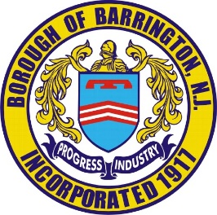
Borough of Barrington Permit No.Click or tap here to enter text.
Construction Department
Barrington, NJ 08007 Issued By:Click or tap here to enter text.
856-547-0706
Date:Click or tap to enter a date.
PERMIT APPLICATION
Sidewalk, Curb, and Driveway Aprons/Ramps
Address of Work: Click or tap here to enter text.
Name of Owner:Click or tap here to enter text.
Owner’s Address: Click or tap here to enter text.
Owner’s Phone Number: Click or tap here to enter text.
Name of Contractor: Click or tap here to enter text.
Contractor’s Address: Click or tap here to enter text.
Contractor’s Phone Number: Click or tap here to enter text.
Contractor’s Certificate of Insurance Provided ☐ Yes ☐ No

Emergency Day Number:Click or tap here to enter text. Contact Name:Click or tap here to enter text.
Night Number: Click or tap here to enter text. Contact Name: Click or tap here to enter text.

Type of Work to Be Performed: Choose an item.
Work to be Performed On: Choose an item.
Length (in feet) to be worked on: Click or tap here to enter text.
Description of work to be performed: Click or tap here to enter text.
☐Approved ☐Unapproved Signature Click or tap here to enter text.
Resident/Contractor has received, read, and understands the specifications and inspection process.

Signature(type name here)Click or tap here to enter text. Date: Click or tap to enter a date.

Sign Here: __________________________________________
A pre-inspection and inspection are required.
Please contact Construction Dept. 856-547-0706 at least 24 hours before to schedule inspection.
**ANYTHING OVER 65 SQUARE FEET THE FEE IS $50.00, ANYTHING UNDER IS $25.00**

