The Barrington Police Department has created a registry for individuals with Autism or disabilities in efforts to give police quick access in an emergency to critical information about a person who is registered. The registry can provide police with emergency contact information, detailed physical descriptions, known routines, favorite attractions or special needs of an individual with Autism Disorder or other disabilities such as: Alzheimer’s, Dementia, Down Syndrome or any other endangered individuals. This information can greatly assist police officers when time is essential in communicating and dealing with an emergency situation involving a person with Autism Disorder as well as other disabilities.
The registration form asks for valuable information that police may need when helping individuals with Autism Disorder or any other disability. We ask that all questions be filled out completely and a current photograph be provided. If you are unable to supply a photograph, we can take one for you. The information you provide is confidential and will only be used by law enforcement.
If any information on the registration changes you are encouraged to inform us as soon as possible. This program is free to the community and another example of the partnership between the BPD and its residents. Please contact the BPD with any questions at 856-547-3350. Completed forms may be turned in at the Barrington Police Station or emailed to Bpdinfo@barringtonboro.com.

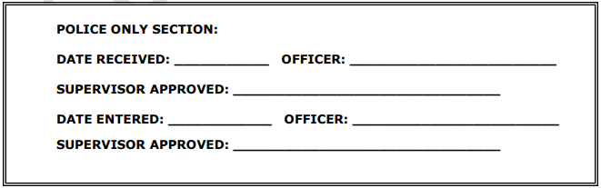

Name:_______________________ DOB:______________________
Nickname (or any name that is most likely to get a response:_____________________________
Address:_______________________________________________________________________
City:_______________________ State:_________________________ Zip Code:_____________
Home Phone:_____________________ Other Phone:___________________________________
Race:_________________ Sex:_______________ Height:_____________ Weight:____________
Hair Color:_______________________ How worn:_____________________________________
Eye Color:_____________________________ Complexion:______________________________
Facial Hair:______________________ Scars or marks:__________________________________
______________________________________________________________________________
School/Employer:________________________________________________________________
_______________________________________________________________________________
Method of communication, if non verbal: sign language, picture boards, written words
Etc:____________________________________________________________________________
_______________________________________________________________________________
Identification worn: ex: Jewelry/Medic alert, clothing tags, ID card, tracking monitor, etc
________________________________________________________________________________
Inclination of wandering of characteristic that may attract:_________________________________
_________________________________________________________________________________
Favorite attractions and locations person may be found:___________________________________
_________________________________________________________________________________
Best methods of approach (include de-escalation techniques):_______________________________
__________________________________________________________________________________
Life threatening medical concerns:______________________________________________________
Any other relevant information:________________________________________________________
Information that will generate a positive response:_________________________________________
Information such as what NOT to do should include: bright lights,noises,direct eye contact, etc:_____
___________________________________________________________________________________
Please attach a recent photo to this form.

Contact Information
Primary Emergency Contact:
Name:______________________________________________________________________________
Address:____________________________________________________________________________
Home Phone:________________________________________________________________________
Work Address:________________________________________________________________________
Work Phone:_________________________________________________________________________
Alternate Phone:______________________________________________________________________
Date of Birth:_________________________________________________________________________
Gender:______________________________________________________________________________
Relationship:__________________________________________________________________________
Email:________________________________________________________________________________
Secondary Emergency Contact:
Name:_______________________________________________________________________________
Address:______________________________________________________________________________
Home Phone:__________________________________________________________________________
Work Address:_________________________________________________________________________
Work Phone:__________________________________________________________________________
Alternate Phone:_______________________________________________________________________
Date of Birth:__________________________________________________________________________
Gender:______________________________________________________________________________
Relationship:__________________________________________________________________________
Email:________________________________________________________________________________

Please feel free to add any additional information that you feel may be helpful.
__________________________________________________________________________________________________________________________________________________________________________________________________________________________________________________________________________________________________________________________________________________________________________________________________________________________________________________________________________________________________________________________________________________________________________________________________________________________________________________________________________________________________________________________________________________________________________________________________________________________________________________________________________________________________________________________________________________________________________________________________________________________________________________________________________________________________________________________________________________________________________________________________________________________________________________________________________________________________________________________________________________________________________________________________________________________________________________________________________________________________________________________________________________________________________________________________________________________________________________________________________________________________________________________________________________________________________________________________________________________________________________________________________________________________________________________________________________________________________________________________________________________________________________________________________________________

